

To: Housing Panel

Date: 5th December 2013

Report of: Head of Customer Services

Title of Report: Rents Performance

Summary and Recommendations

Purpose of report: To provide an update on the performance of the Rents Team.

Executive lead member: Councillor Susan Brown

Recommendation(s): The Committee is recommended to: Note the performance of the Rents Team and the work being undertaken to improve performance on collection of arrears.

Introduction

- At its meeting on 4th November 2013, the Panel requested more information on the profile of the rent arrears figures.
In particular:
- the number of tenants in arrears who are affected by any of the benefit changes and/or in the direct payments pilot; and
- the profile of the debt by number of weeks in arrears.

Performance Figures

- At the 31st March 2013 tenant rent arrears were £1,023,519.80 (2.47 % of rent roll). At week 31 (3/11/13), the figure had risen to £1,144,344.58 (2.62% of the rent roll), an increase of £120,824.78.

- The target collection rate for the year is 97.5%. As at 3rd November the collection rate was 94.5% against a year to date target of 95.4%.

- It is important to understand that arrears can vary due to the timing of housing benefit payments to claimants. Direct Payment tenants are always paid any Housing Benefit entitlement 4 weekly in arrears. For example, between 15/10/13 and 12/11/13 arrears will be accruing, and will reduce on 12/11/13 once Housing Benefit is received and they have the means to make payment of rent due.

- Table 1 below compares the percentage of rent arrears with the same period last year.

Table 1: Arrears Percentage

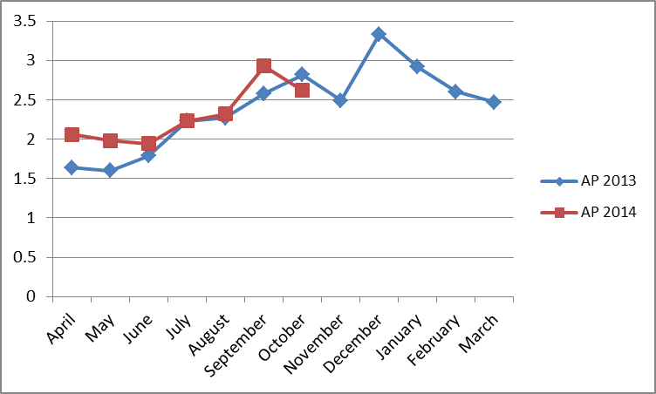

- Table 2 below compares actual arrears with the same period last year. Whilst current year figures have been higher than last year, it shows that arrears are back at a similar level as at the same point last year.

Table 2: Rent Arrears

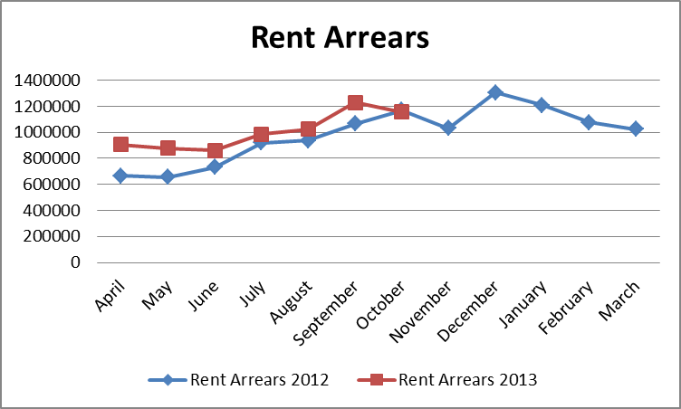
Welfare Changes/ Rent Debt Analysis

- The objective of Phase 1 of the Direct Payments project was to identify those people who could manage the direct payment of housing benefit, those who could not manage direct payment and those claimants who would be able to manage with some support. As an organisation we wanted to find out what the best way of providing that support was. In order to achieve this learning the intention was to include a representative sample of claimants, and therefore whether a tenant was in arrears or not was not a criteria for removing someone from taking part in the project.

- The purpose of Phase 2 of the Direct Payment project was to use the learning from Phase 1 and embed our approach into business as usual. When selecting claimants to put into Phase 2 there were more robust selection criteria and the more vulnerable were not automatically added to the project.

- For Phase 2 participants, much greater emphasis has been placed on supporting the tenant leading up to the start date of the switch to direct payments. There is a dedicated support worker in the Rent team who works closely with Tenancy Support Officers for on-going tenant support. The Welfare Reform Project Team has also been involved, for those affected by the bedroom tax or benefit cap, helping tenants seek alternative sources of income and providing access to Discretionary Housing Payments when appropriate.

- The project benefits from the fact that the collection of rent and the administration of benefit are managed within the same service area. This will not be the case when Universal Credit is implemented, however we wanted to use the degree of flexibility we currently have to prepare our tenants as far as possible for when Universal Credit is introduced.

- Table 3 below shows that of a total 7,725 tenants, 4,716 are in rent arrears as at 3rd November 2013, compared to 2,490 tenants in arrears at the start of the financial year. The total number of arrears cases and value of those cases is shown in the first section of the table. The analysis that follows shows the level of arrears at the start of the year and the level at 3rd November 2013, for cases not in the Direct Payment Project for phases 1 and 2 of the Direct Payment Project and for households affected by bedroom tax. There are only 10 cases affected by the Benefit Cap. The Benefit Cap cases are all subject to a Discretionary Housing Payment award and none of them are currently in rent arrears, and are therefore not shown.

- The increase in rent arrears for non-direct payment tenants is specifically due to the timings of monthly instalments. In particular, Oxford City has over 3,200 tenants paying their rent by direct debit, most of whom will pay for their annual rent in 12 equal monthly instalments. In 2013/14 there will be 53 weekly rent debits, which equates to 4.4 weeks rent being paid each month. In October, which was a 5 week month, this therefore left a balance. For every account set up to discharge the liability for the year, the instalment plan will ensure that each rent account will be £0.00 by the end of the financial year. This explains why further on in the report in tables 6 and 7, there are higher values of tenants shown with arrears aged between 0 and 4 weeks and with arrears under £100.

Table 3: Arrears Breakdown

 | Week 1 - 7/4/13 |  | Week 31 - 3/11/13
OCC Tenants | Sum | £1,018,455.14 | Sum | £1,144,344.58
 | Count | 7711 | Count | 7725
 | Tenants in Arrears | 2490 (32%) | Tenants in Arrears | 4716 (61%)
 | Average | £409.02 | Average | £242.65
Non Direct Payments | Sum | £543,364.77 | Sum | £572,780.68
 | Count | 6400 | Count | 6005
 | Tenant in Arrears | 1398 (22%) | Tenant in Arrears | 2760 (45%)
 | Average | £388.67 |  | £207.53
Direct Payments Phase 1 | Sum | £475,090.40 | Sum | £416,950.92
 | Count | 1311 | Count | 1311
 | Tenants in Arrears | 1092(83%) | Tenants in Arrears | 1041 (79%)
 | Average | £435.06 |  | £400.53
Bedroom Tax | Sum | £151,189.40 | Sum | £165,989.52
 | Count | 601 | Count | 454
 | Tenants in Arrears | 342 (57%) | Tenants in Arrears | 358 (78%)
 | Average | £442.07 |  | £463.66
Direct Payments Phase 2 | Sum |  | Sum | £100,507.40
 | Count |  | Count | 395
 | Tenants in Arrears |  | Tenants in Arrears | 332 (84%)
 | Average |  |  | £302.73

Note: The analysis of arrears in this table does not add up to the total arrears of £1,144,344.58, because some tenants fall into more than one category.

- At the start of the Direct Payment Project Phase 1 in June 2012, 359 tenants had arrears totalling £116,804.45. At the 3rd November 2013 arrears for tenants in Phase 1 stand at £416,950. Following the payment of Housing Benefit in week commencing 10th November, a number of tenants discharged their rent liability and arrears cases in Phase 1 reduced to 950 and the amount of arrears fell to £308,871. Hence it could be claimed that the impact on arrears of Phase 1 of the Direct Payments project was an increase of £196,353. At the start of Phase 2 of the project 77 tenants had arrears totalling £16,136.01. However, it should be noted that some of the impact for arrears rising could be due to other pressures given the current economic climate, especially as some clients in Phase 1 of the project are in receipt of partial housing benefit.

- The arrears profiIe for Phase 1 cases is shown in Table 4 below. It should be noted that these figures include all tenants that have been switched back to direct payment as they were either not able to sufficiently manage direct housing payments or have stopped receiving housing benefit. 358 tenants have been switched back in the pilot.

- No tenant in the pilot is in receipt of direct payments if they are over 10 weeks in rent arrears. Intervention is made in every case where there is 4 to 8 weeks rent arrears, options are discussed with the tenant to assess whether they are able to manage direct payments.

- There is a gradual improvement in the arrears situation, for example in the last four weeks we have seen a total reduction in rent arrears for Phase 1 of £4,247. This includes 352 tenants reducing their rent arrears by an average of £98.02, and 212 tenants increasing their arrears by an average of £142.71.

- It should be noted that out of the 6 direct payment pilots nationally, the last comparison across the pilot sites showed that Oxford City Council had the smallest level of arrears at 3% compared to the poorest performer at 12%. When this was calculated, the arrears for this phase of the project were £184,943, set against a rent debit that had been raised for the period of £6,075,834. It is anticipated that the arrears arising as a result of the Direct Payment project will be underwritten by the Department for Work and Pensions (DWP). This is presently expected to be in region of £200k.

- Oxford City’s participation in the Direct Payments Demonstration Pilot has been positive in many ways. The direct payment project has enabled us to introduce the concept of direct payment of benefit to tenants ahead of time, supporting them throughout. We now engage with tenants who previously did not need to contact the Rent Collection Team, as their rent account was previously paid by a direct transfer of housing benefit. As a result we have become more familiar with these tenants and addressed in good time the many issues they would otherwise have faced for the first time when Universal Credit is finally implemented. In particular we have supported tenants to develop the money management skills they will require. Participation in the project has meant that the City Council has limited the future impact to rent payments. Furthermore, it has also allowed us to influence the design of Universal Credit. The DWP now recognise that significantly more tenants are vulnerable then first expected and through working with landlords we can identify and support these changes. Finally, the DWP is discussing a data sharing agreement with landlords that was not on the agenda at the start of the pilot that will assist both tenants and landlords in Universal Credit.

- We will not be adding any more tenants onto the direct payment project for the rest of 2013/14, whist we continue to support existing tenants and continue to improve the arrears position. We will review the position and decide whether to continue with adding the rest of our tenants into direct payment of their housing benefit in 2014/15.

Table 4: Direct Payments Phase 1 Arrears Profile
Range | Jul-12 | Arrears Cases | Week 31 2013/14 3-11-13 | Arrears Cases
0 to 4 weeks | £32,871.99 | 262 | £181,978.81 | 762
4 to 13 weeks | £55,451.18 | 81 | £180,807.07 | 250
13 to 26 weeks | £20,513.80 | 13 | £45,276.46 | 26
26 to 39 weeks | £7,967.48 | 3 | £8,888.58 | 3
39 to 52 weeks | £0.00 | 0 | £0.00 | 0
 | £116,804.45 | 359 | £416,950.92 | 1041
Range | Jul-12 | Arrears Cases | Week 31 2013/14 3-11-13 | Arrears Cases
£0 to £100 | £4,960.52 | 129 | £4,682.12 | 118
£100 to £250 | £15,950.54 | 96 | £32,319.35 | 178
£250 to £500 | £23,300.70 | 64 | £167,046.86 | 515
£500 to £750 | £15,921.37 | 26 | £67,446.97 | 110
£750 to £1000 | £12,159.90 | 14 | £42,827.43 | 50
£1000 + | £44,511.42 | 30 | £102,628.19 | 70
 | £116,804.45 | 359 | £416,950.92 | 1041

- Table 5 below shows the amount of arrears attributed to cases affected by the Bedroom Tax, those in the Direct Payments project and all the others. The chart shows that the Welfare Reforms have had an effect on our collection of Rent, however we are working proactively with tenants as detailed below to minimise the effects of these changes. Please note that the data sets included in the chart only go as far as Week 29. The data referred to above is for Week 31. Experience from phase 1 suggests that tenants will take a number of months to manage the changes and pay their rent on time. This chart confirms the comment above suggesting that the increase in arrears from Week 17 onwards is mainly influenced by Phase 2 of the direct payments project.

Table 5: Rent arrears with moving trendline
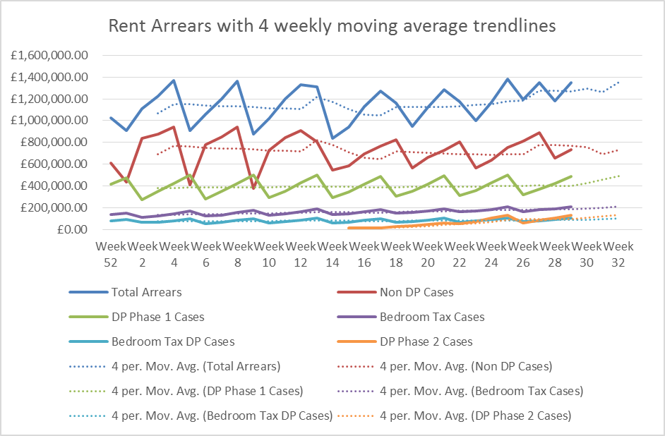
Table 6: Arrears Profile by Age

- Below is the profile of debt by number of weeks in arrears:

Age | Week 52 2012/13 31-3-13 | Arrears Cases | Week 31 2013/14 3-11-13 | Arrears Cases
0 to 4 weeks | £404,759.55 | 1840 | £472,365.56 | 3948
4 to 13 weeks | £368,405.06 | 523 | £451,853.17 | 657
13 to 26 weeks | £193,777.29 | 109 | £177,459.45 | 96
26 to 39 weeks | £51,513.24 | 18 | £42,666.40 | 15
39 to 52 weeks | £0.00 | 0 | £0.00 | 0
 | £1,018,455.14 | 2490 | £1,144,344.58 | 4716

- We have seen an increase in the number of small debts from 0-13 weeks, but we have been monitoring the increase in low level debt and the service is being proactive in tackling these debts. There are no arrears cases over 39 weeks old, and the number of arrears cases between 13 and 39 weeks has also fallen. The team are specifically targeting all accounts in arrears below 6 weeks and contact is being made via phone or letter. This early contact with tenants allows us to support them in managing their rent payments and prevent accounts from progressing into more serious arrears.

Table 7: Arrears Profile by Value of Debt

Range | Week 52 2012/13 31-3-13 | Arrears Cases | Week 31 2013/14 3-11-13 | Arrears Cases
£0 to £100 | £23,370.21 | 565 | £41,392.53 | 2314
£100 to £250 | £71,979.39 | 420 | £115,786.61 | 661
£250 to £500 | £358,205.05 | 967 | £372,380.93 | 1119
£500 to £750 | £133,372.13 | 222 | £184,582.05 | 300
£750 to £1000 | £99,086.53 | 115 | £106,373.65 | 124
£1000 + | £332,441.83 | 201 | £323,828.81 | 198
 | £1,018,455.14 | 2490 | £1,144,344.58 | 4716

- Table 7 above shows the number of arrears cases by value. The number of cases has increased in all but the last range. In the £0-£100 range, the number of cases seems high, but this is largely due to collecting Direct Debits 4 weekly and/or monthly so at a point within a month some of these cases will go back into credit.

- In addition to this, the Direct Payments Project Group are continuing to work with tenants on the scheme and those effected by the under occupancy charge (bedroom tax) by providing support, sign posting money advice and educating tenants on the need to maintain rent payments. This work is to embed a culture of payment to the rent account. With tenants on Phase 1 of the project, we have already gone through the process of seeking advice and assessing support needs.

- The team are committed to sustaining tenancies and continually negotiate payment plans that benefit both the Council and the tenant. In every contact with a tenant the team reviews the last payment plan to ensure arrears are reducing. If a tenant should not adhere to the plans then we will use legal avenues to pursue the debt. Since the introduction of Welfare Reforms the team has noticed the negotiations and conversation are now longer and more difficult. Tenants have a number of issues to deal with and the team are educating tenants in how to adequately pay their rent. The work that the team are doing with Direct Payments and Bedroom Tax is allowing us to improve the service and help tenants through a difficult period of change.

- The team also continue to work with the accounts with the highest arrears to avoid the need to seek possession of the property and to keep the tenants in their homes. The types of interventions being made are:

  - establishing the root cause of non-payment of rent;
  - seeking advice and support for the tenant through advice agencies to assist with prioritising debts as may be being chased for other debts, for example Council Tax arrears;
  - educating the tenants on priorities and how to get independent advice once issues established; and
  - renegotiating rent payments they can afford.

- All arrears cases are reviewed in line with recovery processes on a regular basis in particular debts over 13 weeks. The debts over 13 weeks have a court order or are in the process of applying to court unless there are housing issues involved that are being dealt with in a combined approach across service areas (such as legal issues). The management of Housing and Rents regularly update each other on high level and priority cases. Many of these cases with a court order are subject to a payment arrangement as per the court order. On default, we reapply to the court for a possession order. Judges are often reluctant to give possession at the first hearing; in fact the team may go back to court 4 or 5 times before possession is granted. Even prior to the last court hearing we continue to work with the tenants with a view to sustaining the tenancy.

- A marketing campaign to encourage tenants to remember to pay their rent over Xmas and New Year period is currently being drafted.

Name and contact details of author:-
Name Tanya Bandekar
Job title Service Manager – Revenues and Benefits
Service Area Customer Services
Tel: 01865 252281 e-mail: tbandekar@oxford.gov.uk

List of background papers: None
Version number: 1.1

